

**Star of the Week**

**for working hard and**

**his positive attitude**

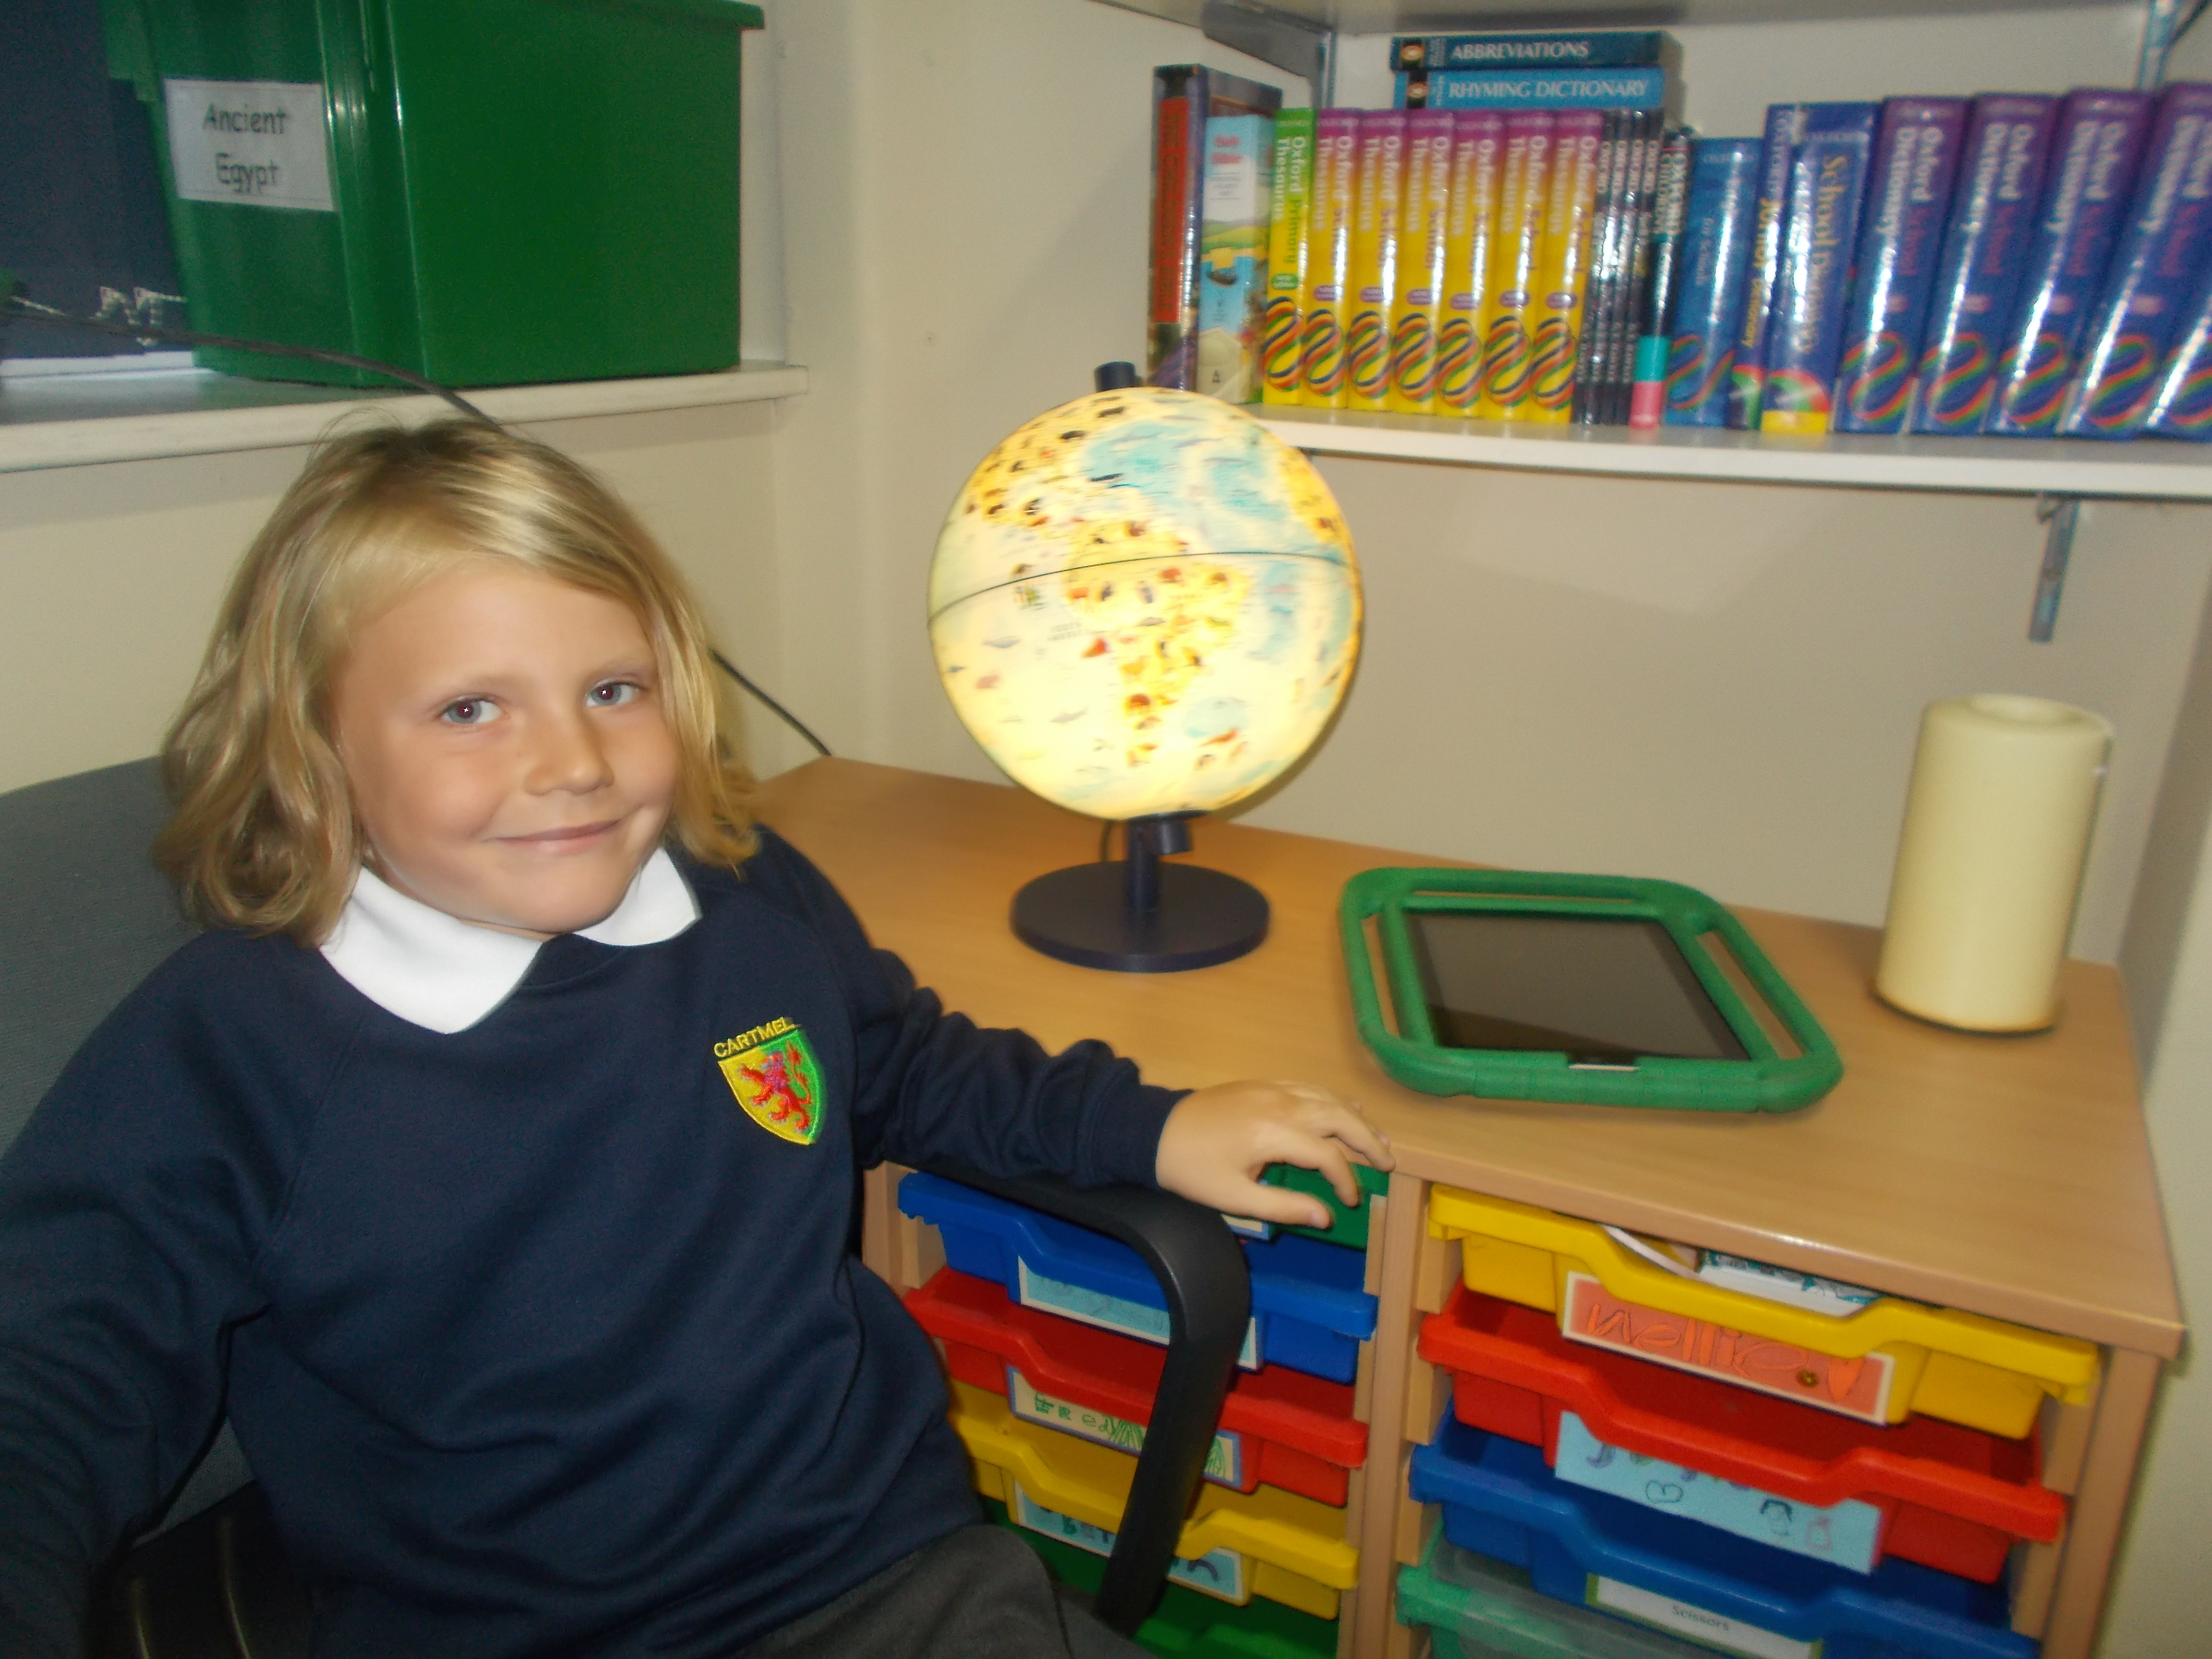

**Ollie**

**Josie**

This week’s

