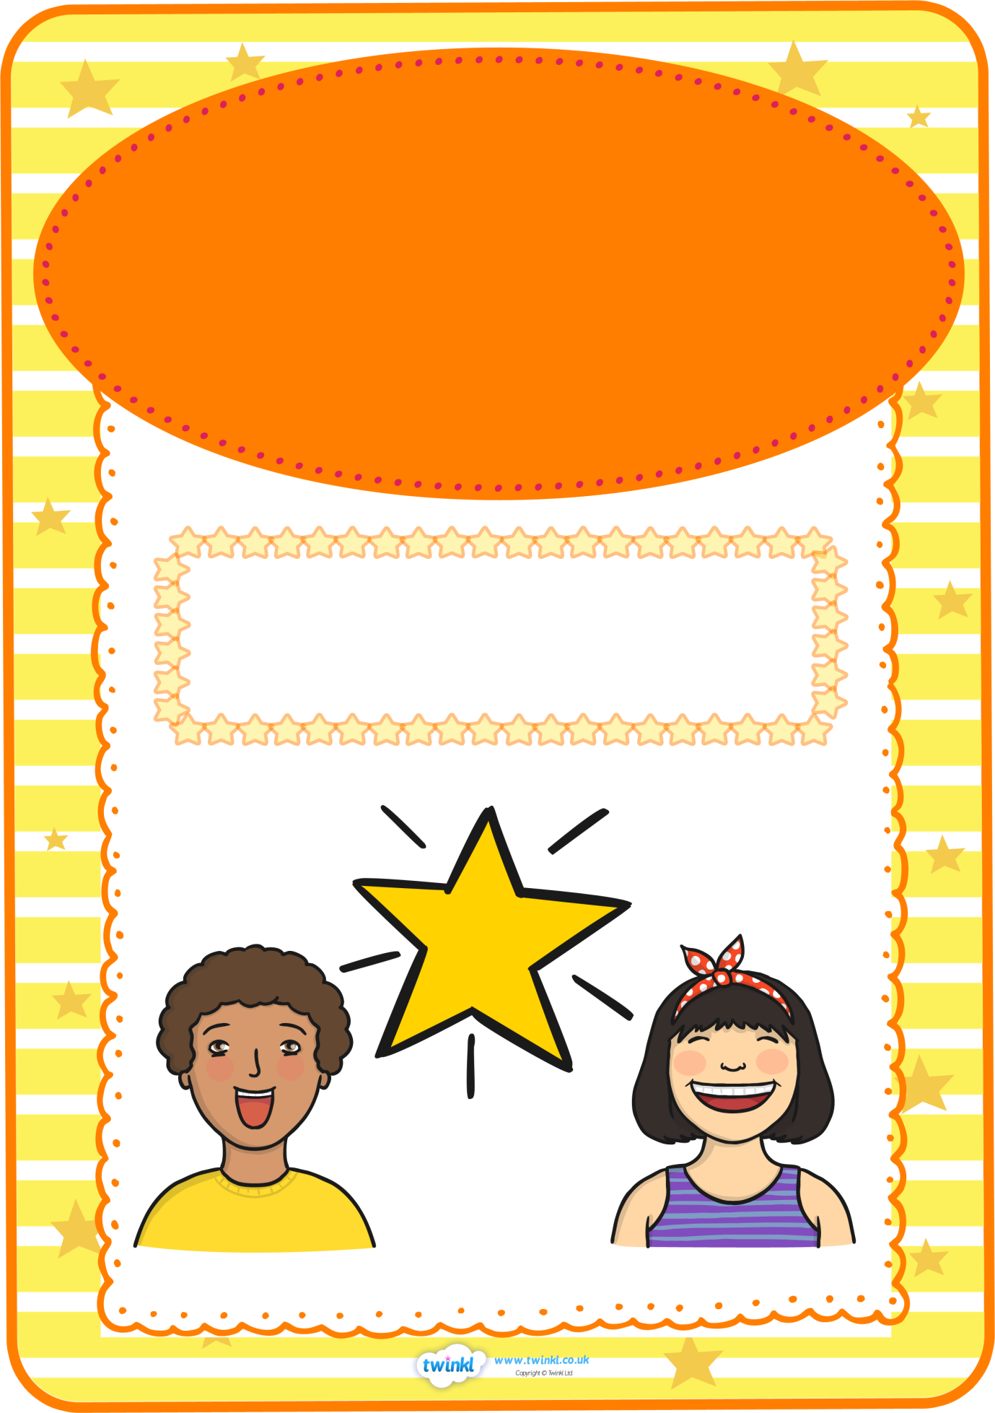

**Star of the Week**

**for working extremely hard**

**and being a great role model**

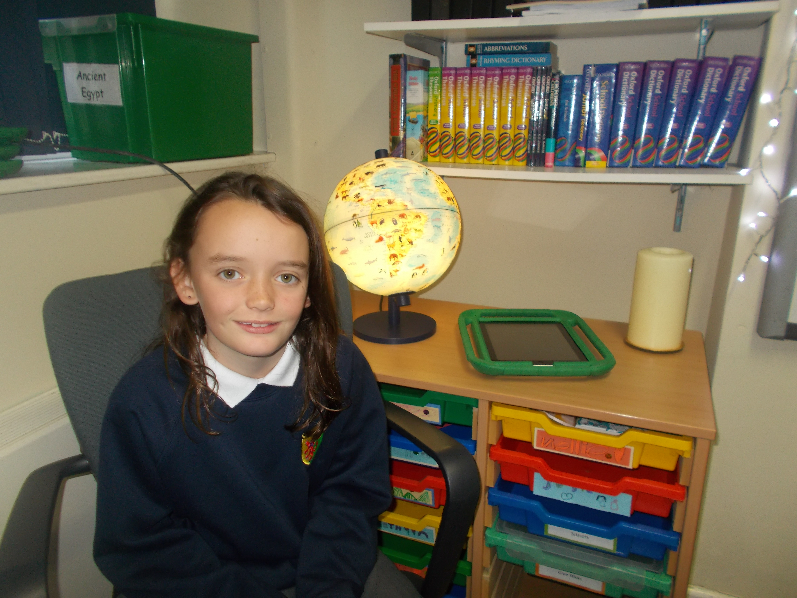

**Annabel**

**Josie**

This week’s

