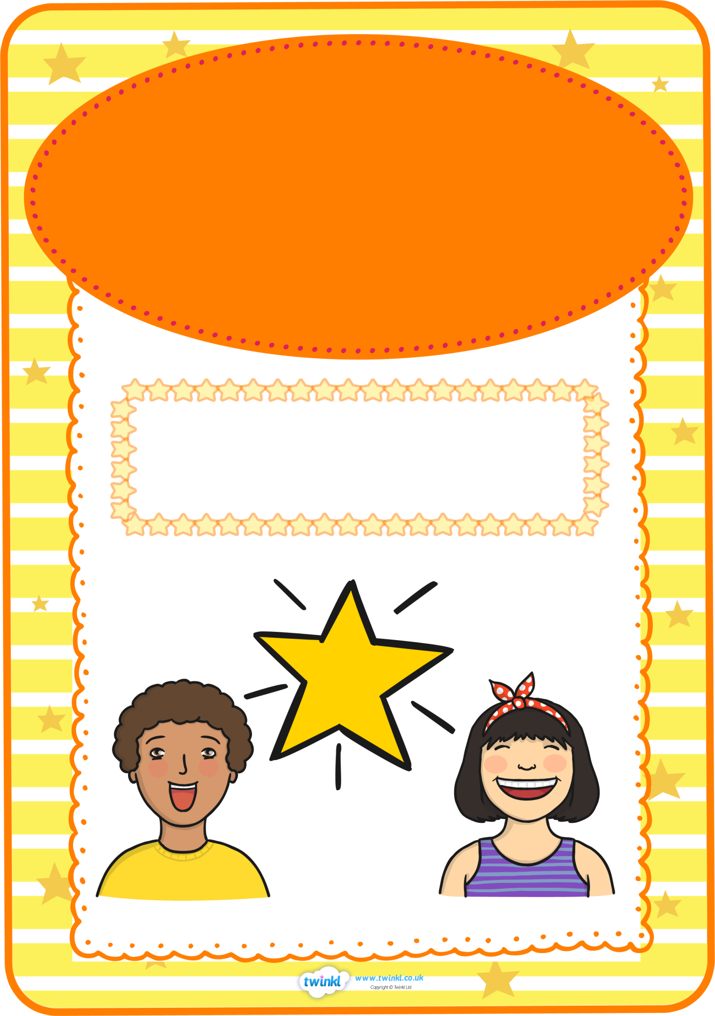

**Star of the Week**

**for her excellent work in maths**

**and positive attitude is**

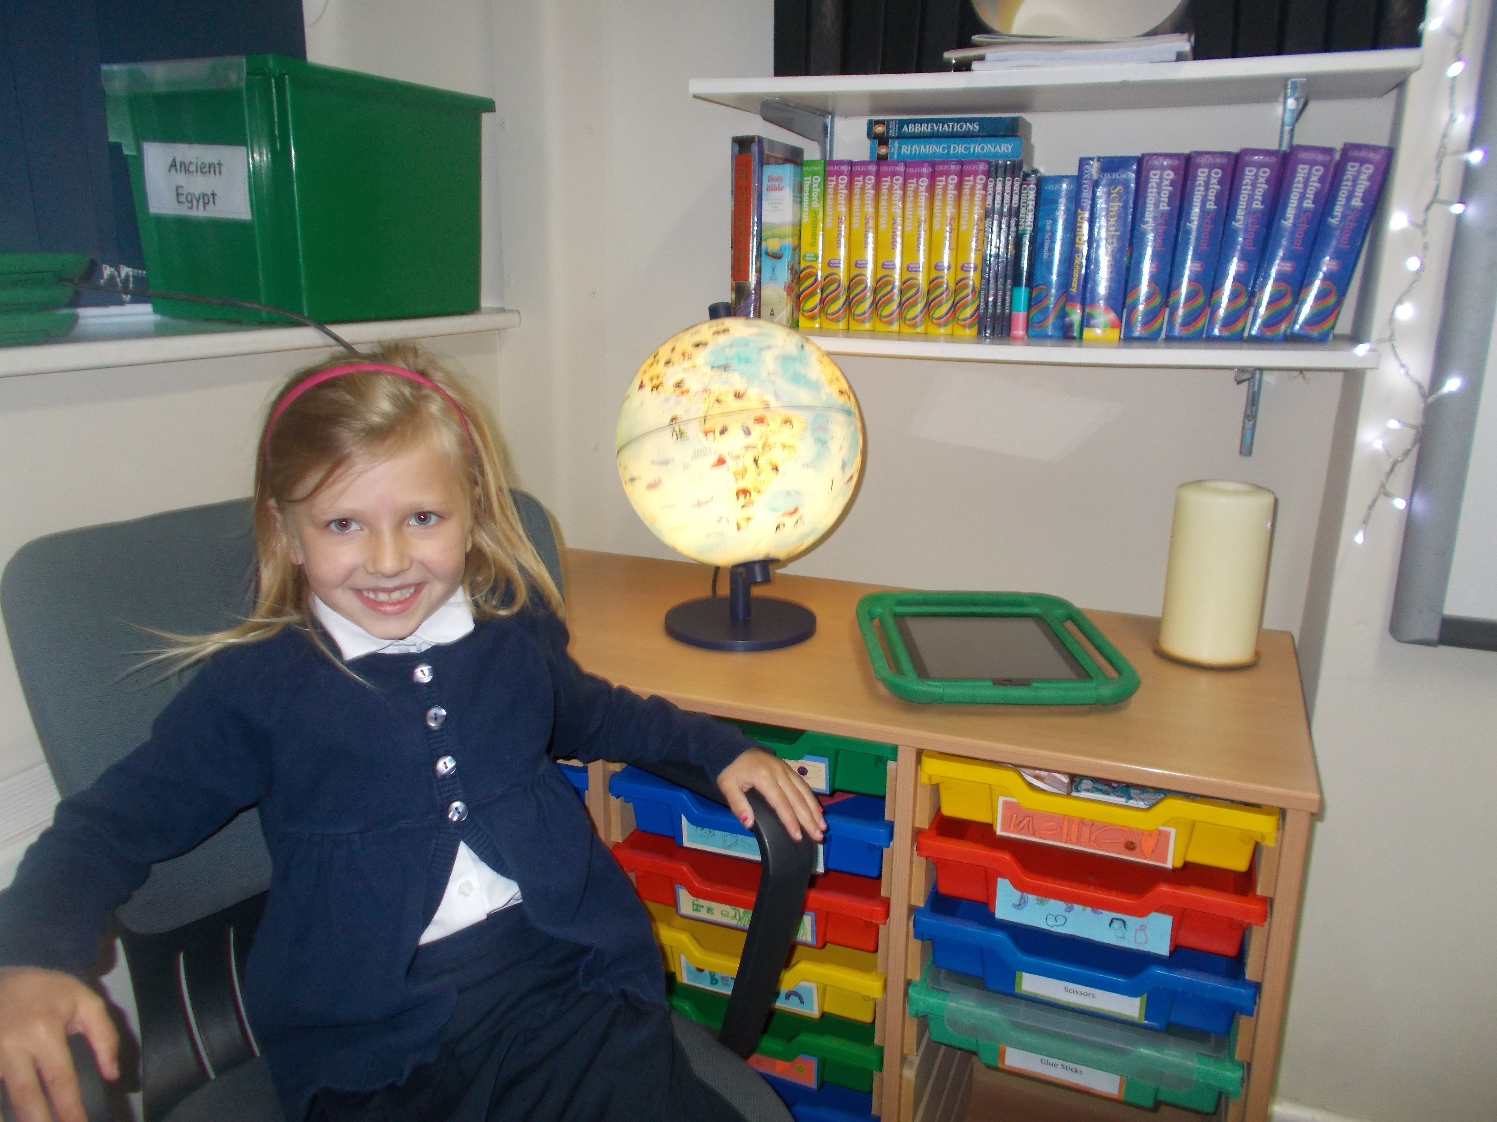

**Zara**

This week’s

