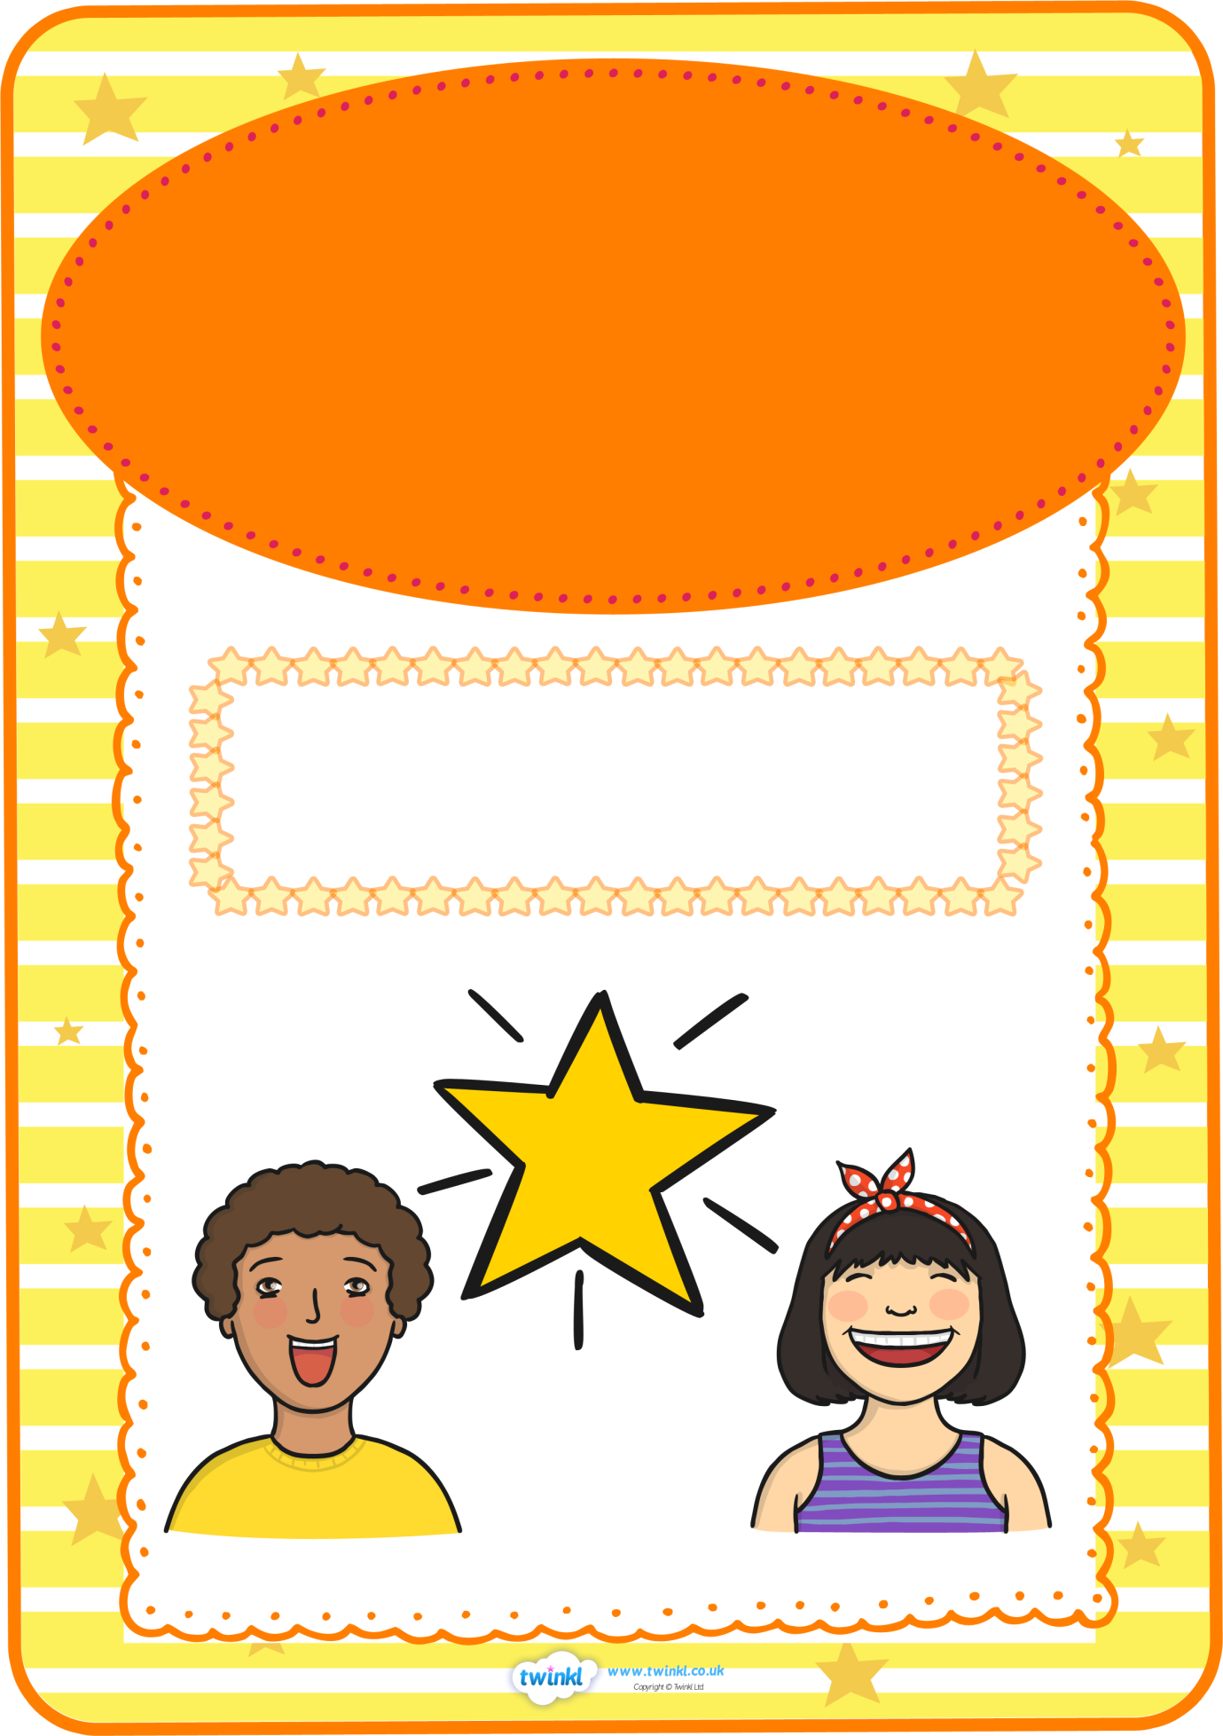

**Star of the Week**

**for his wonderful work in**

**literacy and spellings**

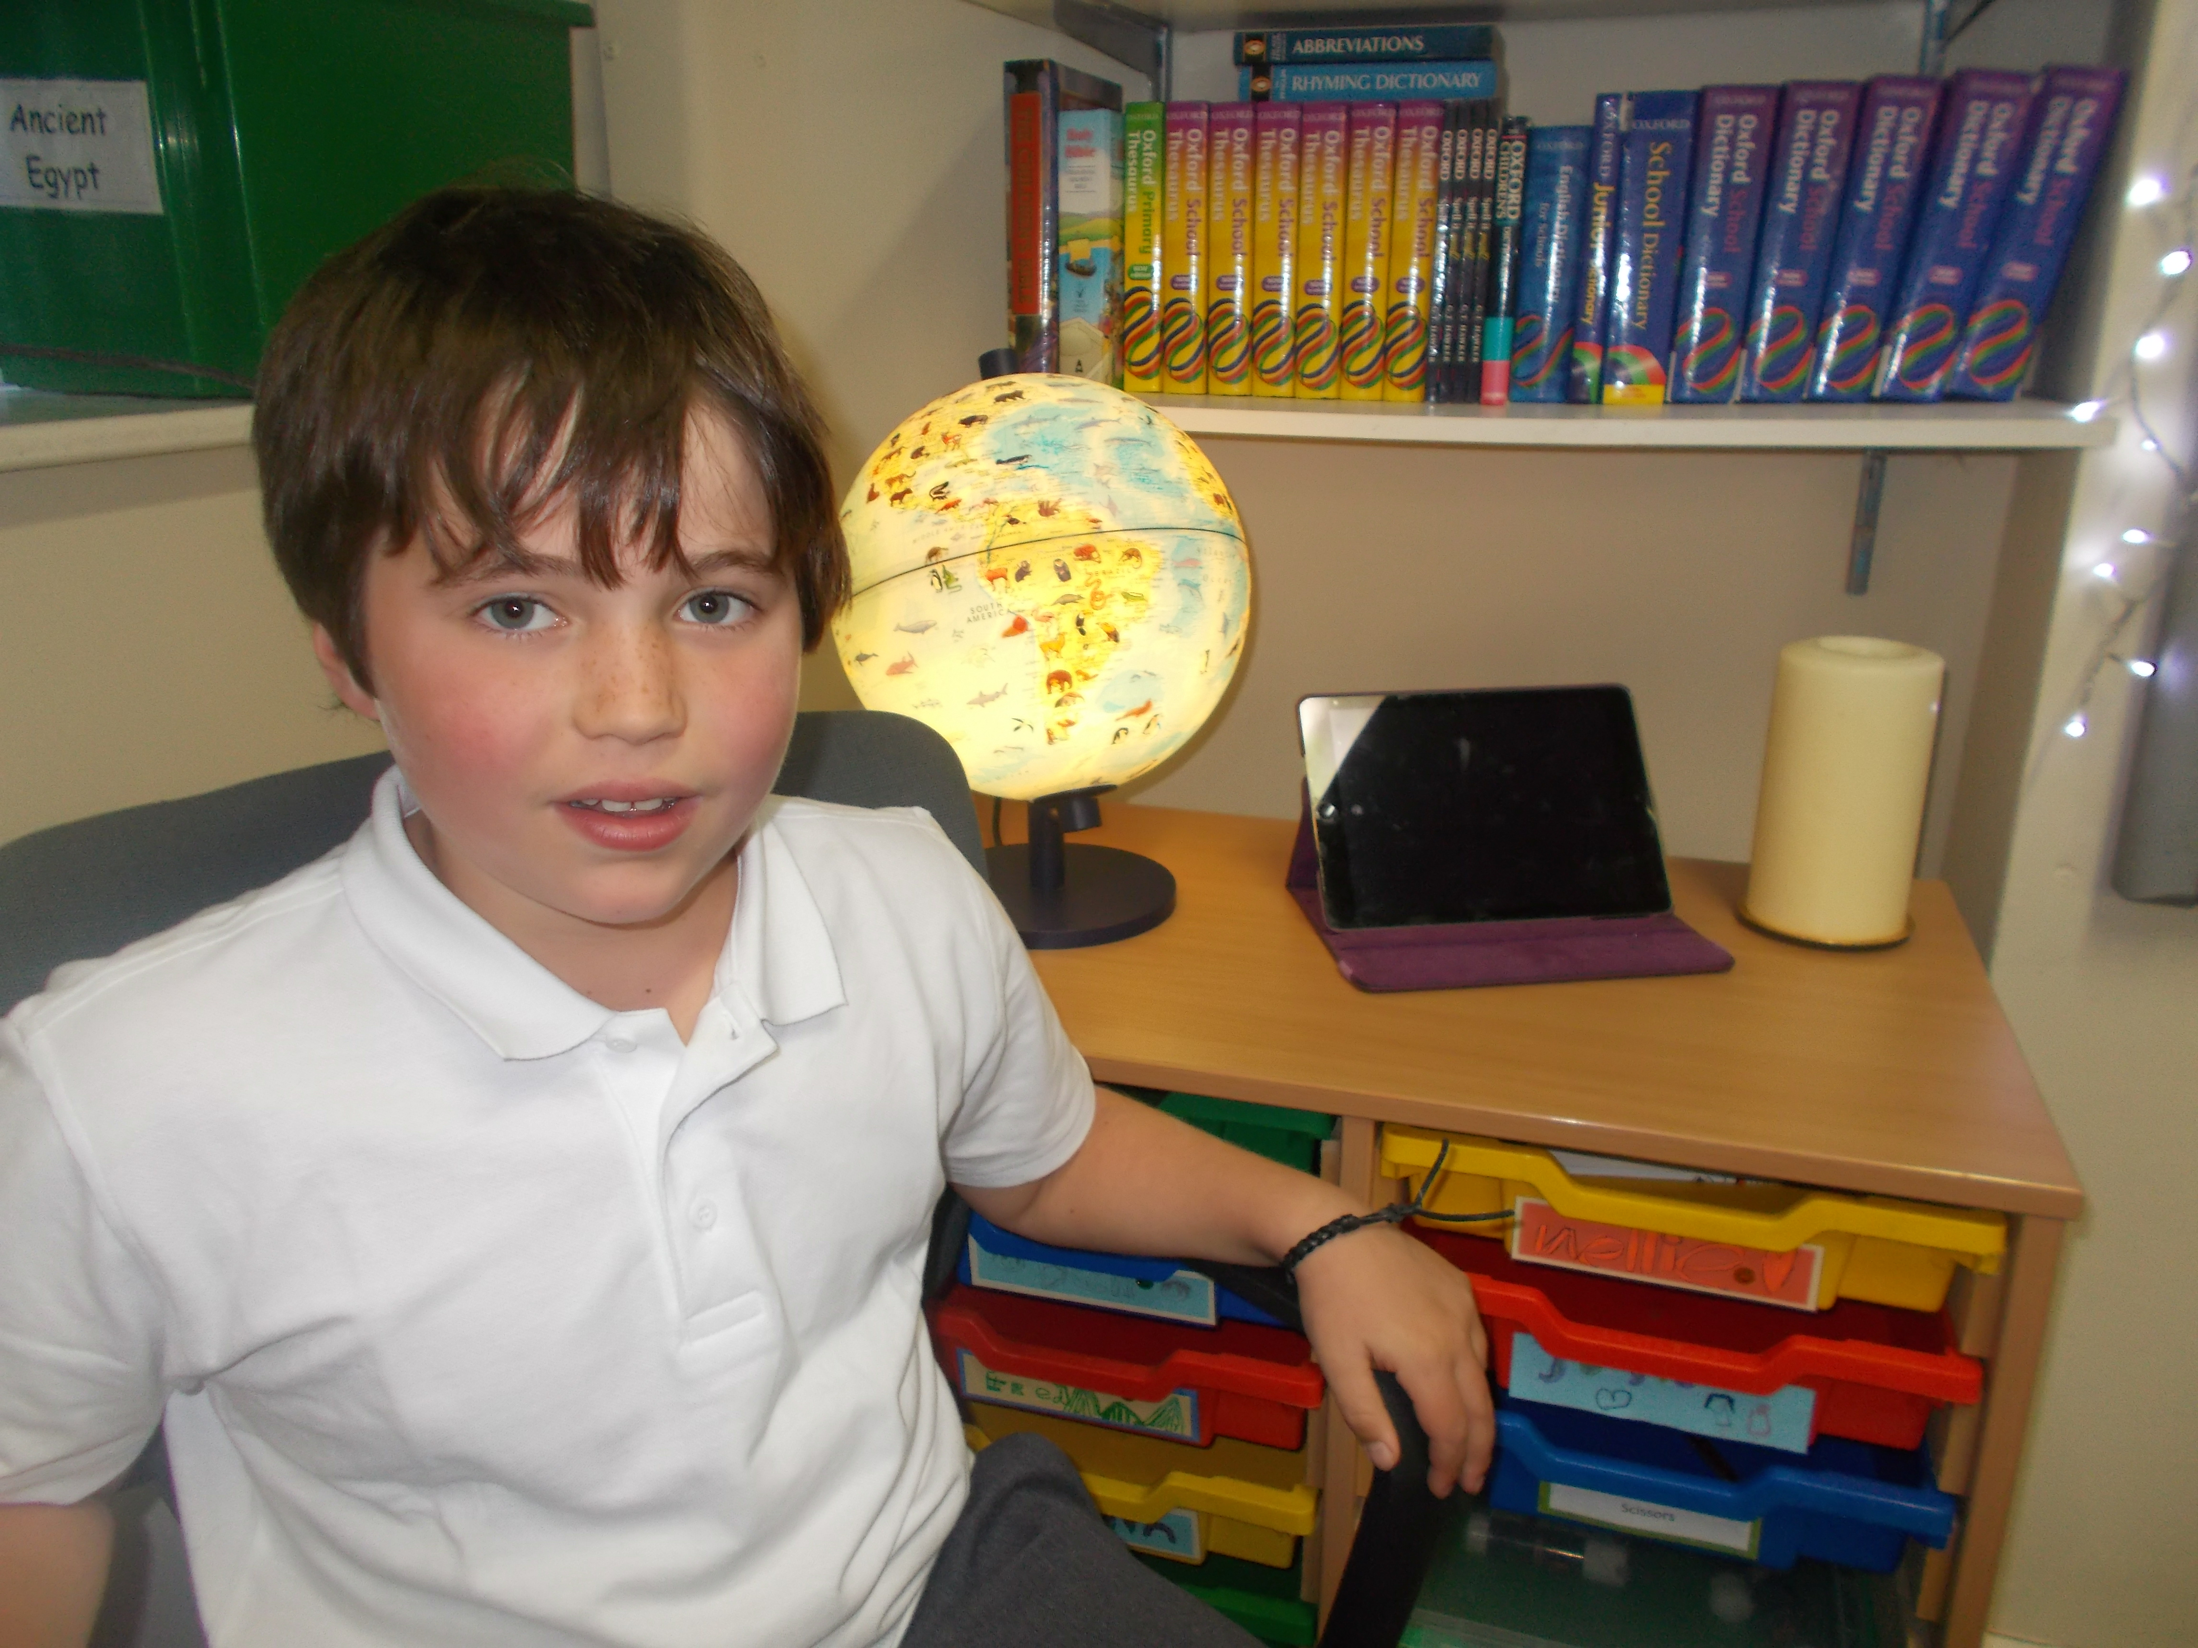

**Freddie**

This week’s

