Home learning: The Last Wolf (Whole-school project)
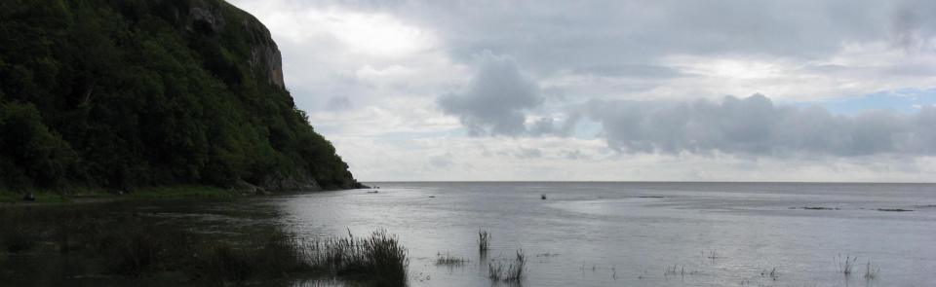
Please find below a table giving a series of lesson objectives and accompanying tasks which could be done to explore each objective. These tasks have been designed with different ages and learning preferences in mind. If you have other suggestions please share them, via the pupil area of the school website or Tapestry (class 1) and we will update the school blog with further ideas.
Background knowledge needed to support your child with these tasks:
Humphrey Head – England's Last Wolf. Legend has it that the last wolf in England was killed a mile away from Lothlorien at Humphrey Head on the shores of Morecambe Bay in 1390. According to folklore, the beast came down from the fells above Coniston where it had been attacking flocks of sheep. https://www.cumbriacountyhistory.org.uk/last-wolf-england-background
“This mean old tale is set during the fourteenth century but written records are comparatively recent. The earliest appears in The Remains of John Briggs (1825). Here we are told ‘a bold and intrepid knight, named Harrington, fixed his abode at Wraysholme’ and ‘erected the Tower’.
In Harrington’s day all the wolves in the south had been killed, but a few remained in the forest of Cartmel. ‘These it was his amusement to hunt, in order to exterminate the breed.’
Whilst hunting on Humphrey Head, Harrington was ‘stopped by the shrieks of a female in extreme peril’. She was trapped in the cleft of a rock by ‘an enormous wolf… his barking was tremendous and death lightened his eyes’. John ‘transfixed the animal with his lance’.
The hapless maiden immediately fell in love with her rescuer and they married. Harrington made the wolf – the last in England – his crest. The ‘happy pair… were buried in a niche in Cartmel church. Their effigies were cut in stone with a figure of the wolf at their feet.’”
https://lornasmithers.wordpress.com/2017/11/26/lancashires-last-wolf/

Lesson Objective | Learning to share with your child | Task A | Task B | Task C
1.To understand that we can learn about events that happened in the past through written accounts. To understand than some historical events were not recorded but were instead remembered and retold. | Share children a story of the last wolf. (Lorna Smithers wordpress document) This is called folk lore – we are not certain that it was completely true. There were no cameras or videos to give definite proof. People told each other stories. Most people couldn’t write so the story might have been told and changed a little bit many times before somebody wrote it down. Almost 500 years after this event occurred a man wrote about it. | Children draw a story map of their own story of how the wolf might have been captured. | Write your own story to explore the legend of the last wolf. Will your story be a retell of the story shared? Or do you have other ideas of what may have happened? | Write a diary entry from the perspective of one of the main people in the story (Harrington? Adela? The Wolf?). Explore their thoughts and feelings – was it really Sir Harrington who was brave, perhaps it was Sir Harrington who was in Peril and Adela who stepped up to brave?
2. To understand that historical events influence the place that we live. | Our area is proud of its history and the wolf is on badges of local schools. We have a wolf on our own school badge and the badge worn by children at Cartmel CofE Priory shows the wolf and represents faith and courage. 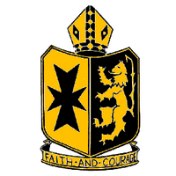 | Children draw their own badge, showing events that are important to them in their own history. | Draw your own badge, showing events which are important to you and your community, thinking about your own history and events in the past. | Look at different local school badges and coats of arms, draw them and research what the different aspects of the badge represent.
3.To understand how perspectives on environmental issues have changed through history. | In 1390 wolves could be dangerous to people as they would enter villages in winter searching for food. Many people were frightened so they wanted to ‘exterminate’ them all. These days we think very differently about animals and like to protect different species. | Design a trap to safely capture a wolf so that it can be moved to a (you could make a trap in your garden) | Read the adult fact sheet about wolves to your child.  Children draw a wolf and write facts about them. | Research about an endangered species. Write information about the animals and give information about how they can be protected.
4.To understand what life was like for peasants who lived in the 14th century. https://www.historylearningsite.co.uk/medieval-england/the-lifestyle-of-medieval-peasants/ | The time of the story of the wolf was called the middle ages. At this time most people lived in the countryside and there were not many towns at all. There was a King who ruled, he had favourite people who were his Lords and Knights and most people were poor peasants. (We would likely have all been peasants!) Peasants had a very hard life doing lots of jobs for the rich people and trying to grow a little bit of food for themselves. They would have lived in a simple wooden hut. (Medieval peasants homes were simple wooden huts. They had wooden frames filled in with wattle and daub (strips of wood woven together and covered in a 'plaster' of animal hair and clay). However, in some parts of the country huts were made of stone. Peasants huts were either whitewashed or painted in bright colours.  The poorest people lived in one-room huts. Slightly better-off peasants lived in huts with one or two rooms. There were no panes of glass in the windows only wooden shutters, which were closed at night. The floors were of hard earth sometimes covered in straw for warmth) | Use sheets, towels and furniture to make your own medieval hut in your home. Act out some of the tasks that Peasants would have done (picking crops, building walls, ploughing the fields, sewing seeds) | Using lolly sticks or other resources from the garden and a tin filled with soil, children design and make their own peasant homes. | Research the life of a peasant. Create a presentation explaining the tasks they had to do and their lifestyle.
5.To investigate the habitats of wolves. To locate places on a map. | Explain that our country has changed a great deal since the story of the wolfs. Most of England was covered in forests. Since then trees have been cut down to make more room for farm land and to make room for cities and towns to be built. | Watch video clips about wolves and their habitats and draw a picture to show where wolves live. | Using the map of the UK, locate Cumbria. Discuss other places in the Uk you have visited. What are the similarities and differences you have noticed? | Using the map of the world, research and identify where wolves live now. What is the climate like in the different places?
Above are suggestions of activities that children could do for their project work. They could produce power points, posters, a video documentary.
If you would prefer more structured activities there will be reading comprehensions and other task sheets attached on the school website.

